**Castelazo – SEQUENCE DIAGRAM**

A sequence diagram describes an interaction among a set of objects participated in a collaboration (or scenario), arranged in a chronological order; it shows the objects participating in the interaction by their "lifelines" and the messages that they send to each other. In simpler words, a sequence diagram shows different parts of a system work in a ‘sequence’ to get something done. Sequence diagrams are time focus and they show the order of the interaction visually by using the vertical axis of the diagram to represent time what messages are sent and when. You should use sequence diagrams to model high-level interaction between active objects in a system; to model the interaction between object instances within a collaboration that realizes a use case; tomodel the interaction between objects within a collaboration that realizes an operation; to show either model generic interactions (showing all possible paths through the interaction) or specific instances of a interaction (showing just one path through the interaction). The benefits of sequence diagram are many. Some of them include that sequence diagrams are that they can be implemented in many different languages, non-coders can do and understand sequence diagrams, and you can see many objects and classes at one time on the same page. The included example will be an ATM interaction. As you will see by the example, you do not need to see the code, but you will still be able to understand how the program works.

ATM EXAMPLE

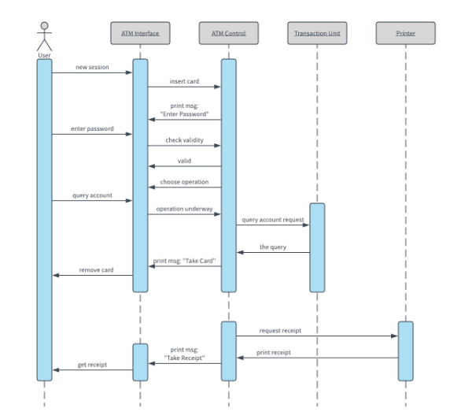

LOGIN EXAMPLE

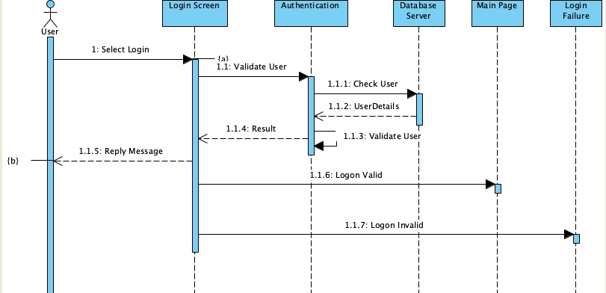

DATABASE QUERY EXAMPLE

